Lumped Parameter Modeling of HCP Metasurfaces at Infrared Wavelengths.
Tao Liu, Chen Zhu, Edward Kinzel

Abstract This paper presents a simple model for Metal Insulator Metal metasurfaces. This includes the presenece of multiple lossy dielectrics. The model is fit from more computationally expensive frequency-domain FEM results. It is validated using microsphere photolithography and FTIR. MPL can be used to rapidly pattern these metasurfaces over large areas. It also supports hiarchical patterning to vary the disk size spatially. The model provides the ability to rapidly synthesize simple metasurfaces for perfect absorbers and reflectarrays including metalenses as well as providing design insight to realizing these devices.

1.0 Introduction
Microbolometers are a common uncooled infrared detector. They are less expensive and more portable than cooled sensors [1]. Microbolometers are heated by absorbing thermal radiation. The increased temperature changes the resistance sensitivity layer’s resistance, which can be detected as output voltage or current signals. Traditional microbolometers are designed to achieve broadband absorption in order to maximize the response from thermal radiation. This is typically accomplished using a quarter wavelength cavity structure. The support legs of the pixel must be placed outside of the cavity which reduces the fill-factor when the microbolometers are arranged in a focal plane array. Using a metasurface to directly absorb infrared radiation removes this requirement and provides a path toward spectral selectivity. These metasurfaces typically include a ground plane and the temperature sensitive resistance layer must be electrically isolated. While the metasurface can be placed above the temperature sensitive layer, serving as a paint, this significantly increases the thermal mass of the microbolometer. Integrating the temperature sensitive resistance layer as part of the metasurface insulating layer improves this but the thickness of the stack must still be selected to achieve the desired absorption [2]. Either configuration allows the supporting legs to be moved under the pixel increase the fill factor. Spectroscopic applications are also potentially enabled by the metasurface. The absorption peak can be tuned by modifying metasurface geometry without changing the thickness of the insolator [3], which simplifies the fabrication of multi-microbolometer arrays. The most common temperature sensitive materials in microbolometers are based on VOx or amorphous silicon. While VOx has a less low frequency noise [4], amorphous has much higher resistivity and lower imaginary permittivity [5].

2.0 RLC Model
Figure 1 illustrates a hexagonal close placed (HCP) metasurface with a dielectric stack and ground plane. The metasurface consists a disk array with diameter d, and periodicity p. The disks are separated from the ground plane by one or more dielectric layers of height h_{diele}. The HCP disk array is selected to match the range of patterns that can be easily patterned using the microsphere photolithography technique. Our objective is to replace full-wave finite element method (FEM) simulation with an equivalent circuit model. This helps understanding the performance of the device as well as permitting rapid synthesis of new designs. After optimizing an equivalent circuit for a given spectra, the results can seed further optimization in HFSS or other FEM solver. This significantly improves the design cycle time.

Figure 1b shows the schematic of the equivalent RLC circuit for the metasurface. The top disk is represented by kinetic inductance, L_{c}, mutual inductance, L_{m} and resistance, R_{c}. The metal ground plane is similarly represented by L_{g}, L_{m} and R_{g}. The gap capacitance C_{m} is used to represent the dielectric layer. The coupling capacitance between adjacent unit cells is represented by C_{e}.

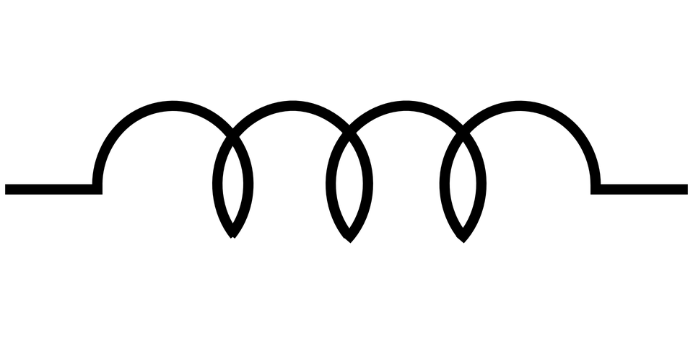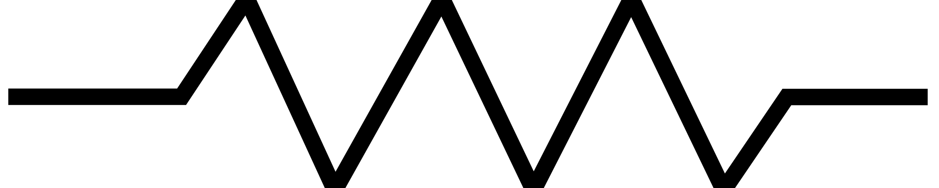
Dielectric layer
Metal
p
d
Metal
C_{m}
C_{m}
L_{m}
L_{m}
L_{c}
L_{g}
R_{g}
R_{c}
C_{e}
C_{e}
(a)
(b)
Oxide layer
…
h₁
h_{n}
Z_{in}
FIG 1. Schematic of (a) hexagonal array metasurface and (b) corresponding RLC model.

The expressions for these elements are given by the following:
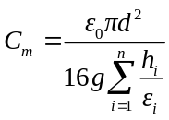 (1a)
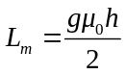 (1b)
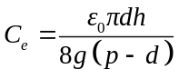 (1c)
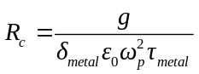 (1d)
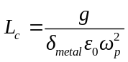 (1e)
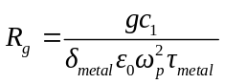 (1f)
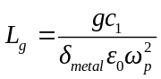 (1g)
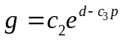 (1h)
where c₁=0.2 c₂=1.672 and c₃=0.589. The coefficient g is used to represent the effects of fringing fields and c₁ is related to the unequal field distribution. These coefficients were fit to a wide range of full-wave FEM simulations (ANSYS HFSS) of HCP metasurfaces with a range of material and geometric properties. The properties of the metals are represented by ω_{p}, τ_{metal} and δ_{metal} corresponding to the plasma frequency, relaxation time, and skin depth, respectively. The dielectric’s properties are given by ε_{i} and h_{i} which represent the permittivity and thickness of i^{th} layer. ε₀ and µ₀ are the vacuum permittivity and permeability.

The total impedance and absorptance the model are
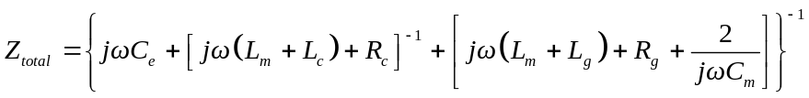 (2)
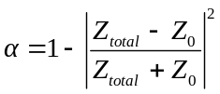 (3)
where Z₀ is the impedance of free space, 377 Ω. The following sections benchmark the performance of the model for different materials.
1.1 Aluminum/Silicon/Aluminum
The first material combination for this metasurface are Al disks separated from an Al groundplane by a Si dielectric. The geometry parameter space for this study is d=[1.1, 1.9] µm with a single dielectric layer is considered in this case. h₁=[0.1, 0.4] µm and a disk spacing, Δp= p – d = [0.2, 3.0] µm. Figure 2 shows a comparison between the RLC modeled and HFSS calculated absorptances. Qualitatively there is good agreement.

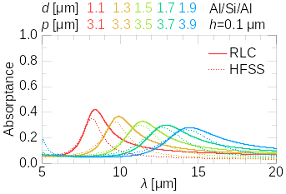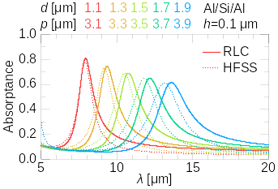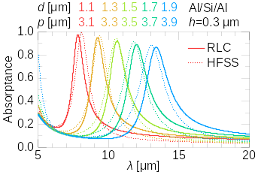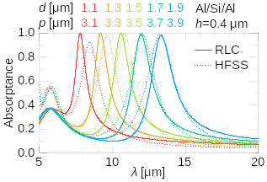
(a)
(c)
(d)
(b)
FIG 2. Comparison between RLC and HFSS calculated absorptances for different geometry Al/Si/Al HCP metasurfaces with h= (a) 0.1 µm, (b) 0.2 µm (c) 0.3 µm and (d) 0.4 µm

1.2 ZnSe and Ge Dielectrics
Figure 3 shows a comparison between the RLC modeled and HFSS calculated absorptances with ZnSe and Ge dielectric models. The geometric parameters were selected to provide near perfect absorptance at different resonant wavelengths. There is good qualitative agreement between the model and simulation near resonance. Fabry-Perot modes appear in thicker Ge layers (HFSS peaks ~5-6 µm). This mode is not captured by the RLC model and results in lower agreement at shorter wavelengths.
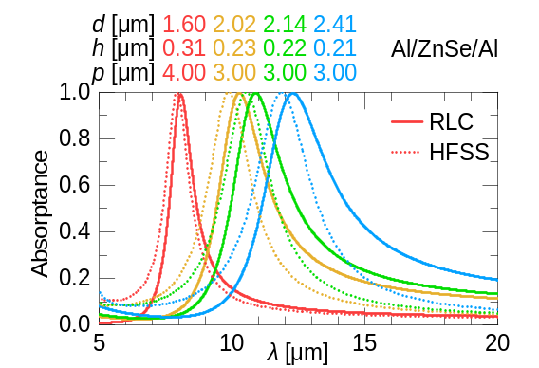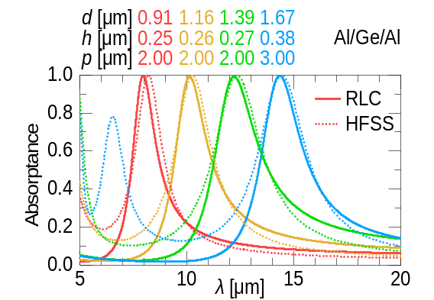
Figure 3. Comparison between RLC and HFSS calculated absorptances for different geometries with ZnSe and Ge dielectrics.

1.3 Silicon Dielectric with Different Metals
Different metals with silicon dielectric layer metasurface were studied. Specifically, Au, Cr and Ni, because their plasma frequencies, relaxation time and skin depths are easily accessible. A comparison between the RLC model and HFSS simulations are shown in Fig. 4, for different geometries producing near perfect absorptance.

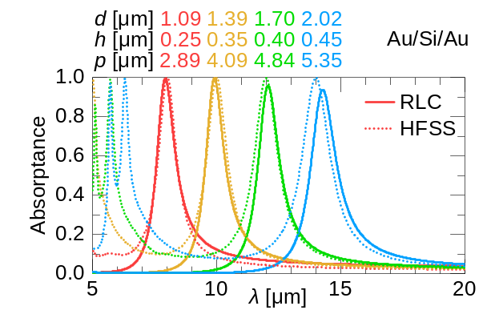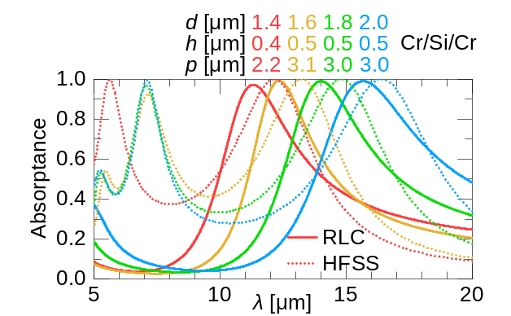
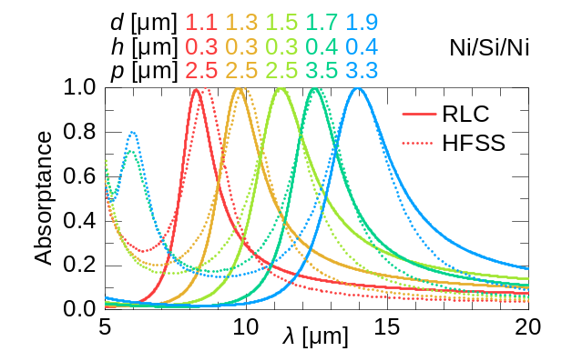
FIG 4. Comparison between RLC and HFSS calculated absorptances for different geometries with Au, Cr, and Ni.

1.4 Multiple Dielectrics Including Oxides with Phonon Modes
Practical microbolometers will require a dielectric layer to isolate the sensing layer from the ground plane. Figure 5 shows results calculated with the RLC model using a multilayer dielectric. Here the wavelength dependent complex permittivity of the oxide layers was used to calculate the capacitance (see Eq. 1). This captures the phonon resonances for these materials. The results show good agreement with full-wave FEM.
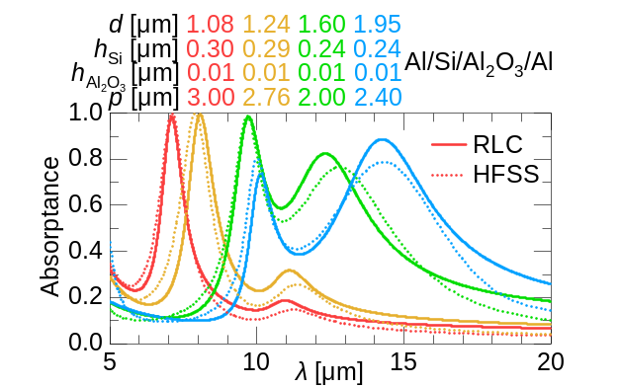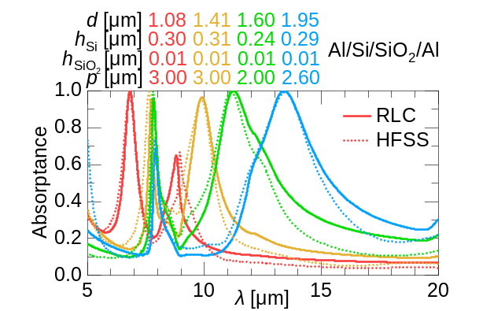
FIG 5. Comparison between RLC and HFSS calculated absorptances for different geometries with alumina and silica multilayer dielectrics.

for a range of

3.0 Experimental Results
Figure 9 MPL Setup
Figure 10 FTIR results comparing experiment and model for Al/Si/SiO2/Al model
Need 3 different cases. At least one perfect absorber.

4.0 Understanding Perfect Absorber Relationships from the RLC Model
The resonant wavelength scales with the disk diameter for low-loss dielectrics such as Si (see Fig. 20). This can be seen by considering the resonant frequency (neglecting losses) for the RLC circuit in Fig. 6.
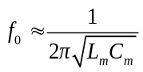 or 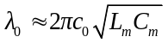 (4)
By substituting Eqs. (1a) and (1b) into Eq. (4), the resonant wavelength final expression can be obtained as
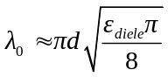 (5)
The periodicity and height terms cancel so that the disk diameter is the only geometric parameter. This simple relationship provides reasonable agreement. Figure 6 shows several different perfect absorbers geometry combinations for different dielectrics. These were optimized in ANSYS Electromagnetics for a range of different periodicities and dielectric heights.
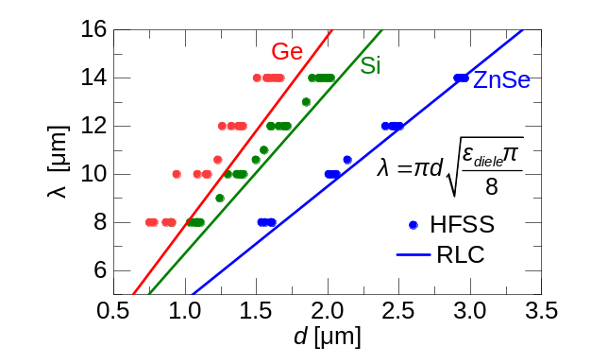
FIG 6. Comparison between HFSS optimized resonant wavelength λ₀ and Eq. (3) for a range of periodicities and dielectric thicknesses

At resonance the imaginary part of the total impedance is 0.
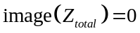 or 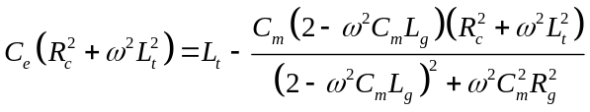 (6)
When 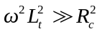 and 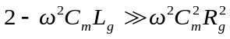. Equation (11) can be simplifies to
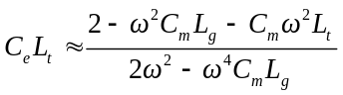 so that 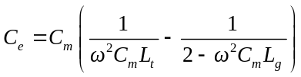 (7)
Substituting all or the definitions from Eq. (1) into Eq. (7) gives
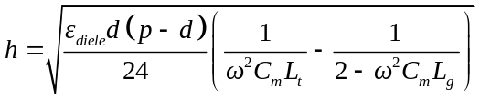 (8)
For a single dielectric layer. For a perfect absorber at resonance, 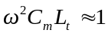 and 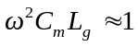.
Approximating 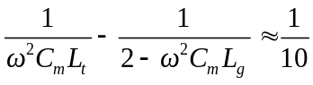 (9a)
simplifies Eq. (13) to 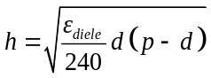 (9b)
The height of the various perfect absorbers is calculated using Eq. (9b) and shown in Figure 6. This is compared optimized heights using HFSS for the same conditions

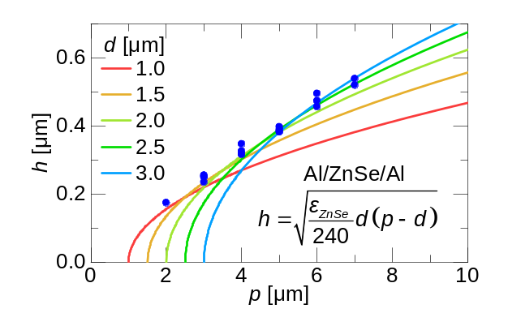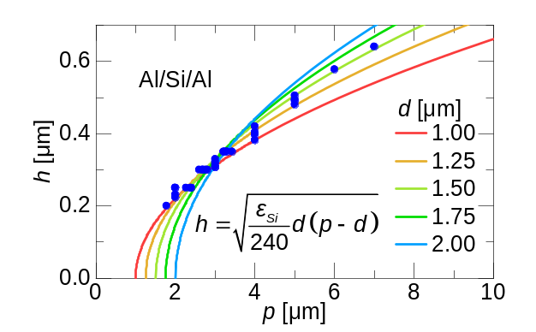
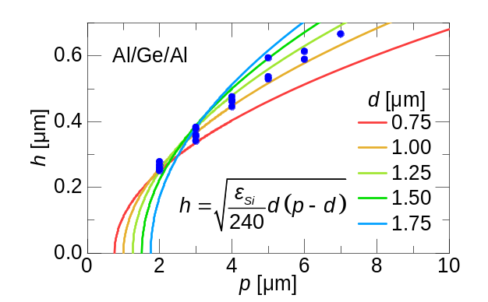
FIG 7. Comparison between HFSS optimized resonant height and Eq. (9b) for a range of dielectrics and disk diameters.

The real part of the permittivity of the dielectric can simplified to ε_{diele} ≈ n² – k², where n is the refractive index and k is the extinction coefficient, if the imaginary portion is neglected. This is reasonable for low loss tangents. Substituting this into Eq. (9b) gives
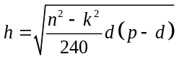 (10)
This agrees with the simulated decrease in the dielectric height for lossy dielectrics.

5.0 Conclusion

Acknowledgement

References
1. C. Jansson, U. Ringh, and K. C. Liddiard. "Theoretical analysis of pulse bias heating of resistance bolometer infrared detectors and effectiveness of bias compensation," In Infrared technology XXI, vol. 2552, pp. 644-652. International Society for Optics and Photonics, 1995.
2. E. M. Smith, J. Nath, J. Ginn III, E. P. Robert, and S. David "Responsivity improvements for a vanadium oxide microbolometer using subwavelength resonant absorbers," In Infrared Technology and Applications XLII, vol. 9819, p. 98191Q. International Society for Optics and Photonics, 2016.
3. L. Tao, Q. Chuang, A. Mahmoul, and K. Edward. "Design and analysis of frequency-selective surface enabled microbolometers," In Infrared Technology and Applications XLII, vol. 9819, p. 98191V. International Society for Optics and Photonics, 2016
4. A. Ahmed, and R. N. Tait. "Noise behavior of amorphous GexSi1− xOy for microbolometer applications," Infrared physics & technology 46, no. 6 (2005): 468-472.
5. A. Roberto, M. Mario, M. J. Jose, T. Alfonso, K. Andrey, and H. Aurelio. "An overview of uncooled infrared sensors technology based on amorphous silicon and silicon germanium alloys," Physica Status Solidi C 7, no. 3-4 (2010): 1180-1183.
6. E. Awad, N. Al-Khalli, M. Abdel-Rahman, N. Debbar, and M. Alduraibi. "Design and optimization of microbolometer multilayer optical cavity," In AIP Conference Proceedings, vol. 1653, no. 1, p. 020017. AIP Publishing LLC, 2015.
7. C.F. Middleton, and G.D. Boreman. "Technique for thermal isolation of antenna-coupled infrared microbolometers," Journal of Vacuum Science & Technology B: Microelectronics and Nanometer Structures Processing, Measurement, and Phenomena 24, no. 5 (2006): 2356-2359.
8. R. L. Olmon, B. Slovick, T. W. Johnson, D. Shelton, S.-H. Oh, G. D. Boreman, and M. B. Raschke. "Optical dielectric function of gold," Phys. Rev. B 86, 235147 (2012)
9. E. D. Palik, ed. "Handbook of optical constants of solids," Vol. 3. Academic press, 1998.
10. Tatian, Berge. "Fitting refractive-index data with the Sellmeier dispersion formula." Applied optics 23, no. 24 (1984): 4477-4485

